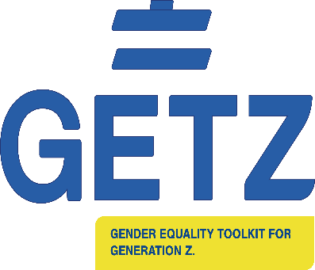



  
**GETZ Steering Group-Meeting 6**

**University of Worcester Via Microsoft Teams**

**Time:** 12.30

**Apologies: Alma Papic**

1. Matters Arising and Actions from previous meeting

2. Conference Review

3. Partner College updates re 2021 Roll out – numbers completed

5. Financial up date (CD)

7. Research – Publication Plan

8. Sustainability Plan

9.Project Final Report and Project sign off

On line Social!